How to configure OBS for capturing multiple sources

- Visit https://obsproject.com/download and download/install the version that fits for your operating system (OS). The screenshots you see in this guideline were made with Microsoft Windows, so steps on other platforms may look different in visual design.

- Connect webcam and microphone and be sure they installed properly on your computer. Test them and adapt gain for microphone(s) and settings for your webcam. (The presenter will stand behind a lectern and talk into a speaker’s microphone - on a stand, connected by cable. The webcam will be about 2m away.)

- Run OBS Studio and click on File – Settings. Click on Stream at the left side and be sure your Stream Type is set to “Streaming Services”. At Service select “YouTube / YouTube Gaming” from the push-down-menu (at first run the default selection is: Twitch). The server is “Primary YouTube ingest server”.
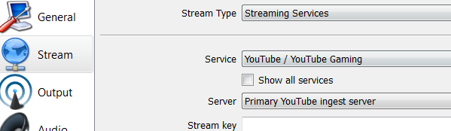

- Click on Output at the left side and find Recording Path. There you should browse a path to a hard disk with enough disk space to make a backup recording in case there is a problem with the streaming in YouTube. A half-hour recording (keynote) can use up to 1 GB. The other settings can be kept as recommend by default (please check below).

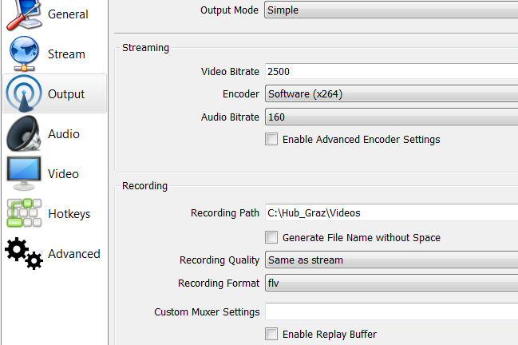
- Click on Audio at the left and find the pushdown menu next to Desktop Audio Device. This is the audio setting for audio from a presentation (e.g. musical example).
  - If examples are played on your computer’s soundcard you can select Default. This means the audio source for the stream is your default output signal based on the settings of your OS.
  - If you are using external devices or other sources which are not set as the default output device on your machine, please make sure you connect them properly and select the external device based on the name and channels of your hardware. You can select up to two different devices.

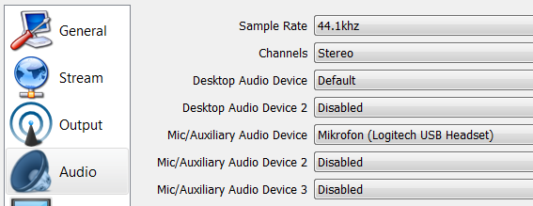

- Stay on Audio, find the pushdown menu next to Mic/Auxiliary Audio Device, and select your input device(s) for the speaker(s). In this example screenshot, we do not use the default input device but an external microphone named Logitech USB Headset. The way to select the correct device is similar to the paragraph above and depends on your hardware configuration and the configuration of the machine’s audio mixer.

- Select Video, find the pushdown menu next to Common FPS Values, and select 20. Keep the other settings as listed below.
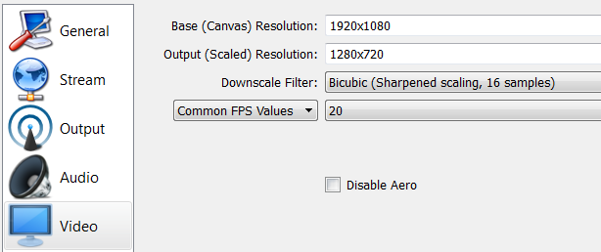
- Click on OK. Next, a rectangular area of the computer monitor screen is selected for streaming. This is called a scene. The scene also includes the position of the talking head and the audio input configuration (OBS thinks the word “scene” includes audio, perhaps they read Bregman’s book? Only joking)

- Click on Scene Collection in the menu bar, select New and enter a name e.g. ICMPC-ESCOM-Scene and click on OK.

- You should see a black picture and underneath different areas. We will resume configuring the input devices starting with Mixer, which contains the audio sources, which were added in 5), and 6).

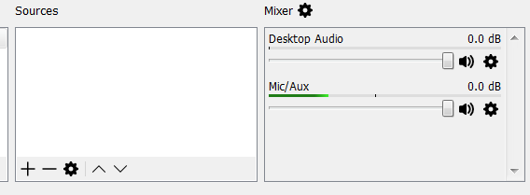

- With the faders, you can control the balance between your sources. This can be changed while streaming/recording. Please make sure your hardware is configured properly in your OS settings or soundcard (e.g. microphone gain).
  - Optional: If you click on the little wheel next to your audio device, you can add effects, e.g. noise suppression for your microphone.

- In the next steps the screen area for streaming the content of a presentation is added. Click on + in the Sources area and select Display Capture.
- Be sure Create new is selected and give it a name, in this case Display Capture, and click on OK. Be sure Make source visible is ticked on.

- In the next window the device’s display is shown. In the push-down menu Display select the same device as is set for the data projector of the audience. If necessary Capture Cursor can be ticked off. Click on OK

- Your configuration is displayed in Sources and the black picture should now contain the display content. By selecting the added source and clicking on the little wheel, the configuration can be changed.

- In the next steps, a capturing device for the talking head (webcam) is added as a source. As before click on + in the Sources area but this time select Video Capture Device.

- Be sure Create new is selected and give it a name, in this case Webcam, and click on OK. Be sure Make source visible is ticked on.

- Find the push-down menu next to Device and select your video input device: in this case Integrated Webcam. You can improve the quality of your input by clicking on configure Video. The other settings can be left as recommended by the software. Click on OK.

- The added input device is now displayed in the area of your display capture. You can drag it around and adapt its size by clicking and dragging it with the red corners. Please adapt the size so it fits to the blank space of the presentation template.

- Your configuration has been saved automatically. You can now click on Scene Collection and Export to save your settings in a file.

