GAPS2017 Technical Guidelines
Daniel Reisinger and Richard Parncutt, April 2017

This document is for technical assistants at all hubs of the GAPS2017 conference. We always invite questions and suggestions and will update accordingly.

Content

1. General Concept 3
a. Flow Diagram 3
b. Moodle 4
c. Basic Requirements for streaming with YouTube Live 4
d. Why YouTube? 5
e. Quality 6
2. How to create and schedule streams with YouTube Live 7
a. 10 Step Guide 7
3. How to configure OBS for capturing multiple sources 11
a. 20 Step Guide 11
4. How to connect OBS and YouTube for streaming 16
a. 20 Step Guide 16

- General Concept

  - Flow Diagram
This diagram describes the basic concept of our streaming method. Details follow on the next pages.
YouTube
(streaming host)

Moodle
(platform)

- Runs the presentation for both real and online audience
- Webcam and Microphone capture the speaker
- Encoder-Software creates stream with screen content and speaker’s head and audio
- Stream is uploaded based on a key for YouTube-Live
- One account per hub is organizing a stream schedule with description
- For each stream a key is generated which is required for the Host-PCs encoder
- Videos are broadcasted as unlisted which means only people with the exact URL have access
- After a stream happened it is being automatically archived and online edited (unlisted)
- View-Statistics (countries etc.)

Presentation
(screen content)
HOST-PC

- The audience can stream live and watch videos from the archive on all devices which support YouTube based on secret links from Moodle
- Discussion and comments should be made in Moodle, while a YouTube account allows live chatting next to the streaming window

- The links for the live streams and archived videos are provided on Moodle
- Only authorized people can access the addresses
- Discussion and comments are possible (without YouTube-Account)

Online
Audience

  - Moodle
This is a teaching platform for which University of Graz has a license. For each course the teacher can upload and change materials. The students can view and download materials and contribute to the discussion forum. At the conference we will use Moodle internationally rather than within the university. Active conference participants will be like teachers and passive like students. Active participants will be given access to the system after they register and will then get their own username and password. They will then have the opportunity to upload any additional materials to accompany their presentation. Everyone will have access to the URLs for each talk (one for the stream during the talk, another for the video afterwards) and to discussion forums. The platform is password protected. Each user will be given an account with individual username and password by the technical team in Graz.

  - Basic Requirements for streaming with YouTube Live
You will need:
- A YouTube/Google Account with a confirmed phone number

- Internet connection with at least 1200kbit/s of stable Upstream
  - HD-Streams (720/1080p) at least 5000kbit/s Upstream. Please conduct a series of tests e.g. with speedtest.net in the rooms where the conference will be held and at different times of day.

- Windows/Linux/Mac (PC or Laptop)
  - CPU AMD FX 6000/8000 series or Intel Core i5/i7
  - 4 to 8 GB RAM
N.B.: This is especially important for the PC used for streaming as it encodes the AV signal. If power is too low it can lead to time delays or lags.

- HD-Webcam for the speaker‘s head in the presentation. Good lighting is important. A light behind the camera or from the speaker’s pult can help. Please experiment.

- Microphone (connected/available for the streaming PC)
  - We suggest classical speaker’s microphone clipped to the speaker’s clothes, either cable (for better quality) or radio/Bluetooth (if the speaker likes to walk around).

- Mixing the two sound signals (microphone and sound files on the computer)
  - One option is to have two devices, one is a USB (e.g. Bluetooth microphone) and the other is the built-in sound chip. They can then be mixed by the broadcasting software.
  - Another option is a separate audio interface box that mixes the two signals.

- We will use a streaming software like OBS (https://obsproject.com/download). The talking head in the corner can be created with the video capture device in OBS. You can use a webcam on a laptop especially if it is HD (high definition) 720 pixels or more. It is also possible to use a separate webcam.

  - Why YouTube?
YouTube offers a free and stable environment as well as a fast and reliable server structure around the world for live streaming. Both viewers and streamers find it intuitive to us. With a confirmed YouTube account, streams can be started or prepared for a delayed start within minutes (the main task is the configuration of the broadcasting software). Each hub that is sending a live stream will need a separate account.
In YouTube it is possible to preconfigure streaming sessions, specifying the date and time and determining the URL in advance which can then be copied into Moodle so any conference participant can connect to the stream.
Comments during streams and after talks can be collected either in YouTube or in Moodle (we will experiment and decide later).
A YouTube live stream can be unlisted, which means only people who have the exact URL can watch it. While the stream is live, people with a Google/YouTube-Account can comment. When the stream stops, the video is automatically archived including the comments. Comments can then be continued in a separate place, the live chat. Both lists of comments can be unlisted so they are only available to persons who know the exact URL. All the URLs can be shared on any password protected platform (e.g. Moodle).
Once a live stream is automatically archived, it can be easily and quickly edited with YouTube directly in the browser without working with local files on the PCs. This is useful e.g. for color/audio correction or creating small text overlays, subtitles etc. for the archived videos. We will avoid local AV-editing which is very resource intensive and consumes a lot of time and disk space.

  - Quality
The quality of the video image depends on the hardware (a PC that is able to encode/process HD-content with good resolution) and the stability of the internet connection. YouTube will only compress a file (reducing the quality) if the user agrees (click on settings – quality) or selects automatic. Resolution of streamed videos during the conference should be either 720 pixels (high definition HD) or 1080 (full high definition FHD), giving audiences the option of selecting lower resolutions. FHD requires an internet connection of at least 5000kbit/s upstream.

- How to create and schedule streams with YouTube Live

  - 10 Step Guide
The transmission can be set up a long time before the presentation (an hour, a day, a week) as follows.
- After login with your certified YouTube/Google-Account click your profile picture on the upper right corner and select “Creator Studio”:
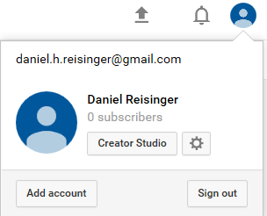
- Your dashboard appears which shows several different widgets which can be customized. Click on “Live Streaming” in the Creator Studio menu on the left side.

- Select the submenu “Events” on the left side and click on the button “New live event” at the upper right corner:

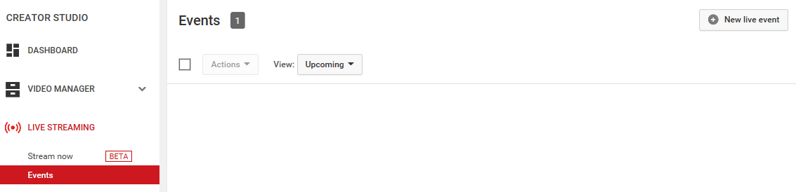
- The following settings and description page will allow you to specify the title, date and time of the stream. The description contains the name of the speaker and the title of the talk (or list).

  - Insert the following in the “Title” field: presentation no., first author, first few words of title, hub,, Date (Swedish Format), Time in GMT/UTC. Example: 79, Smith, Perception of rhythmic pulse, Montreal, 2018-08-25, 18:00.
  - For the “description” field insert the APA reference like this: Ranney, M., Cheng, F., Garcia de Osuna, J., & Nelson, J. (2018, July). Music psychology: A wonderful thing to do. Paper presented at the 15th International Conference on Music Perception and Cognition (ICMPC) combined with the 10th triennial conference of the European Society for the Cognitive Sciences of Music (ESCOM), <HUB>.”
  - Leave the tags field blank for the moment.
  - Select the time zone and start and end times as in the program (which will be presented in Google Spreadsheet).
  - Any of these details can be changed later either before or after the talk.

- To the right of the title: the Push-Down-Menu (red circle) is set to “Public” by default. Be sure you change this to “Unlisted”. The type underneath should be “Custom”. Click on one of the “Create Event” buttons at the right side.
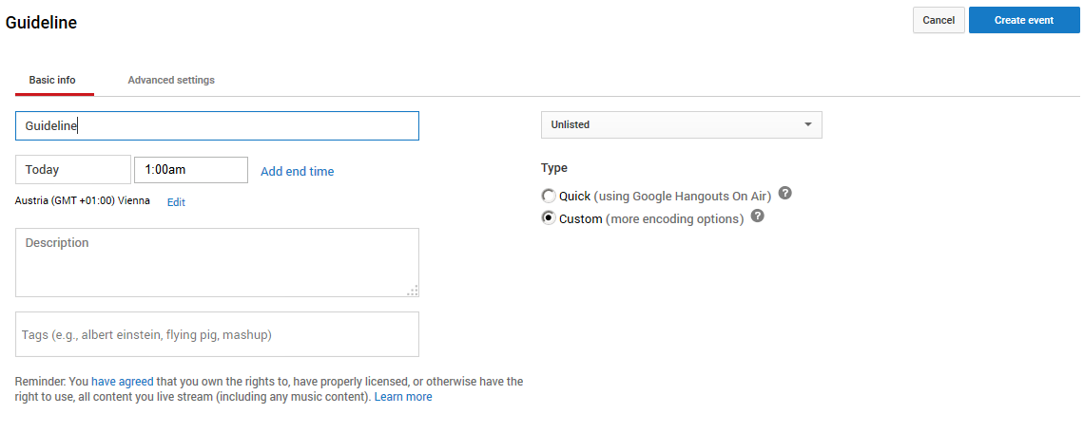
- We will prepare an image in jpg format that will appear before each talk starts with the name and logo of the conference. At the next page click on “Browse” next to “Thumbnail”, upload this image. The image will disappear automatically at the scheduled start time of the talk.
- Right below “Thumbnail” you will find a text field for “Camera Name”. You can leave the default name “Main Camera”. Please select “Basic ingestion” and click on the push-down menu “Select bitrate” and select set it to 3000 Kbps – 6000 Kbps (1080p).
- After selecting the bitrate the options will expand. This page shows important information about encoder settings and the links to correctly set up your encoder software. Select Other encoders from the push-down menu (selected by default).
- Point 2 below, Copy and paste into your encoder, is very important. Please save this data in a file and copy it into the globally available spreadsheet in Google Docs.
- If the above information is correct (stream name etc.), you know that your event has been created successfully. But you still have to click on the blue button “Save changes” at the upper right corner to finish the process.

- How to configure OBS for capturing multiple sources

- 20 Step Guide

- Visit https://obsproject.com/download and download/install the version that fits for your operating system (OS). The screenshots you see in this guideline were made with Microsoft Windows, so steps on other platforms may look different in visual design.

- Connect webcam and microphone and be sure they installed properly on your computer. Test them and adapt gain for microphone(s) and settings for your webcam. (The presenter will stand behind a lectern and talk into a speaker’s microphone - on a stand, connected by cable. The webcam will be about 2m away.)

- Run OBS Studio and click on File – Settings. Click on Stream at the left side and be sure your Stream Type is set to “Streaming Services”. At Service select “YouTube / YouTube Gaming” from the push-down-menu (at first run the default selection is: Twitch). The server is “Primary YouTube ingest server”.
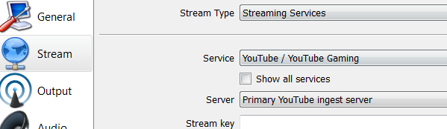

- Click on Output at the left side and find Recording Path. There you should browse a path to a hard disk with enough disk space to make a backup recording in case there is a problem with the streaming in YouTube. A half-hour recording (keynote) can use up to 1 GB. The other settings can be kept as recommend by default (please check below).

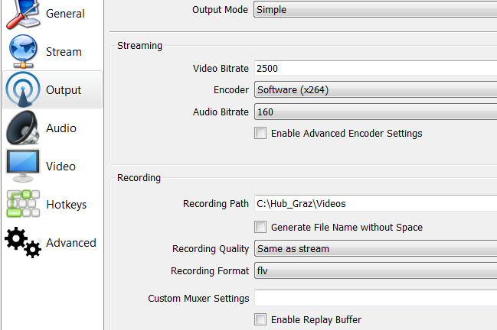
- Click on Audio at the left and find the pushdown menu next to Desktop Audio Device. This is the audio setting for audio from a presentation (e.g. musical example).
  - If examples are played on your computer’s soundcard you can select Default. This means the audio source for the stream is your default output signal based on the settings of your OS.
  - If you are using external devices or other sources which are not set as the default output device on your machine, please make sure you connect them properly and select the external device based on the name and channels of your hardware. You can select up to two different devices.

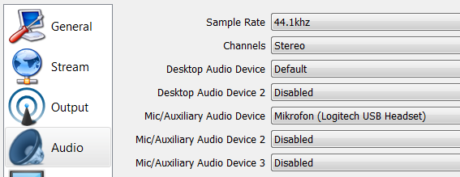

- Stay on Audio, find the pushdown menu next to Mic/Auxiliary Audio Device, and select your input device(s) for the speaker(s). In this example screenshot, we do not use the default input device but an external microphone named Logitech USB Headset. The way to select the correct device is similar to the paragraph above and depends on your hardware configuration and the configuration of the machine’s audio mixer.

- Select Video, find the pushdown menu next to Common FPS Values, and select 20. Keep the other settings as listed below.
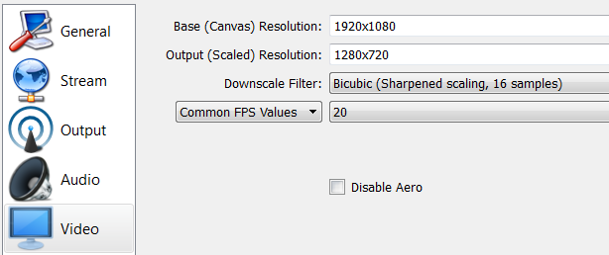
- Click on OK. Next, a rectangular area of the computer monitor screen is selected for streaming. This is called a scene. The scene also includes the position of the talking head and the audio input configuration (OBS thinks the word “scene” includes audio, perhaps they read Bregman’s book? Only joking)

- Click on Scene Collection in the menu bar, select New and enter a name e.g. ICMPC-ESCOM-Scene and click on OK.

- You should see a black picture and underneath different areas. We will resume configuring the input devices starting with Mixer, which contains the audio sources, which were added in 5), and 6).

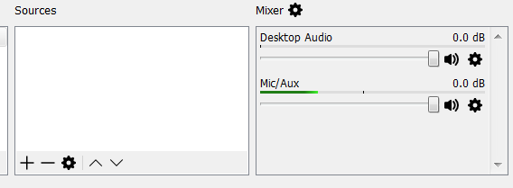

- With the faders, you can control the balance between your sources. This can be changed while streaming/recording. Please make sure your hardware is configured properly in your OS settings or soundcard (e.g. microphone gain).
  - Optional: If you click on the little wheel next to your audio device, you can add effects, e.g. noise suppression for your microphone.

- In the next steps the screen area for streaming the content of a presentation is added. Click on + in the Sources area and select Display Capture.
- Be sure Create new is selected and give it a name, in this case Display Capture, and click on OK. Be sure Make source visible is ticked on.

- In the next window the device’s display is shown. In the push-down menu Display select the same device as is set for the data projector of the audience. If necessary Capture Cursor can be ticked off but this might be useful for pointing at presentations. Click on OK

- Your configuration is displayed in Sources and the black picture should now contain the display content. By selecting the added source and clicking on the little wheel, the configuration can be changed.

- In the next steps, a capturing device for the talking head (webcam) is added as a source. As before click on + in the Sources area but this time select Video Capture Device.

- Be sure Create new is selected and give it a name, in this case Webcam, and click on OK. Be sure Make source visible is ticked on.

- Find the push-down menu next to Device and select your video input device: in this case Integrated Webcam. You can improve the quality of your input by clicking on configure Video. The other settings can be left as recommended by the software. Click on OK.

- The added input device is now displayed in the area of your display capture. You can drag it around and adapt its size by clicking and dragging it with the red corners. Please adapt the size so it fits to the blank space of the presentation template.

- Your configuration has been saved automatically. You can now click on Scene Collection and Export to save your settings in a file.

- How to connect OBS and YouTube and stream

- 10 Step Guide
Once you scheduled a stream in YouTube Live as described in 2. and if you have configured OBS as described in 3. you are ready to stream.

- Start OBS and make sure it is your configuration and all your devices are active and working.

- Go to https://www.youtube.com/live_dashboard and login with your account. You should see the live dashboard. The position of the elements on this page is customizable, the screenshots contain the standard positioning. Scroll down and find “Encoder Setup” in the middle of the page.
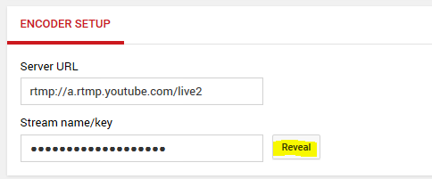

- Click on “Reveal” next to “Stream name/key”. You will see a key consisting of numbers and letters. Copy this key (Ctrl+C).

- Switch to OBS and the menu bar “File – Settings”. It opens a window where you click on “Stream” at the left menu bar.

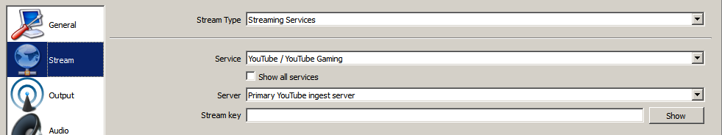

- Make sure your settings correspond to the ones at the picture above and paste your stream key in the field “Stream key” (Ctrl+V).

- Click on “Start stream” at the lower right corner in OBS.

- Switch to the YouTube Live Dashboard. At the top of your page it should show the following:

- It might take a few seconds until you see your stream picture inside the browser. Your stream is now online an can be seen by people with the corresponding URL.

- If your stream is finished, switch to OBS and click on “Stop stream” at the lower right corner

- Once your stopped your stream you can switch to YouTube Live and select the menu “Video Manager” at the left. You can find your stream here. After processing is finished you can cut and enhance quality within functions in YouTube. Your stream is available under the URL. Be aware that the processing after cutting/enhancing it may takes a while until your archived video is available again.

